**Networking Case**

For Bluejack 15-1 By: RZ 14-0

* **Subnetting**

1. A company has a network address 172.16.0.0/16. The company need to divide the network address for the company’s division as following:
   1. Division 1: 2000
   2. Division 2: 7000
   3. Division 3: 3000
   4. Division 4: 4000
   5. Division 5: 6000
   6. Division 6: 1000

Note: use FLSM class B

FLSM

Sort Division :

Division 2 Space Host 7000 -> 13 (8192) -> ambil ‘/19’

Division 5 Space Host 6000 -> 13 (8192) -> ambil ‘/19’

Division 4 Space Host 4000 -> 12 (4096) -> ambil ‘/19’

Division 3 Space Host 3000 -> 12 (4096) -> ambil ‘/19’

Division 1 Space Host 2000 -> 11 (2048) -> ambil ‘/19’

Division 6 Space Host 1000 -> 10 (1024) -> ambil ‘/19’

IP : Divisi 2 : 172.16.0.0 - 172.16.31.255

(Yang kepake dari 172.16.0.1 - 172.16.31.254 )

-- 172.16.0.0 : Network

-- 172.16.31.255 : Broadcast

IP : Divisi 5 : 172.16.32.0 - 172.16.63.255

(Yang kepake dari 172.32.0.1 - 172.16.63.254 )

-- 172.16.32.0 : Network

-- 172.16.63.255 : Broadcast

IP : Divisi 4 : 172.16.64.0 - 172.16.95.255

(Yang kepake dari 172.32.64.1 - 172.16.95.254 )

-- 172.16.64.0 : Network

-- 172.16.95.255 : Broadcast

IP : Divisi 3 : 172.16.96.0 - 172.16.127.255

(Yang kepake dari 172.32.96.1 - 172.16.127.254 )

-- 172.16.96.0 : Network

-- 172.16.127.255 : Broadcast

IP : Divisi 1 : 172.16.128.0 - 172.16.159.255

(Yang kepake dari 172.32.128.1 - 172.16.159.254 )

-- 172.16.128.0 : Network

-- 172.16.159.255 : Broadcast

IP : Divisi 6 : 172.16.160.0 - 172.16.191.255

(Yang kepake dari 172.16.160.1 - 172.16.191.254 )

-- 172.16.160.0 : Network

-- 172.16.191.255 : Broadcast

1. Divide the network address 192.168.1.0/24 with VLSM:
   1. Division 1: 80
   2. Division 2: 12
   3. Division 3: 40
   4. Division 4: 30

Note: count as efficient as possible for the IP use.

Define the network address and broadcast address for each subnet!

VLSM

Sort Division :

Division 1 Space Host 80 -> 7 (128) -> ambil ‘/25’

Division 3 Space Host 40 -> 6 (64) -> ambil ‘/26’

Division 4 Space Host 30 -> 5 (32) -> ambil ‘/27’

Division 2 Space Host 12 -> 4 (16) -> ambil ‘/28’

IP : Divisi 1 : 192.168.1.0 - 192.168.1.127

(Yang kepake dari 192.168.1.1 - 192.168.1.126)

-- 192.168.1.0 : Network

-- 192.168.1.127 : Broadcast

IP : Divisi 3 : 192.168.1.128 - 192.168.1. 191

(Yang kepake dari 192.168.1.129 - 192.168.1.190)

-- 192.168.1.128 : Network

-- 192.168.1.191 : Broadcast

IP : Divisi 4 : 192.168.1.192 - 192.168.1.223

(Yang kepake dari 192.168.1.193 - 192.168.1.222)

-- 192.168.1.192 : Network

-- 192.168.1.223 : Broadcast

IP : Divisi 2 : 192.168.1.224 - 192.168.1.239

(Yang kepake dari 192.168.1.225 - 192.168.1.238)

-- 192.168.1.224 : Network

-- 192.168.1.239 : Broadcast

* **Packet Tracer**

There are 3 routers in a network that will be connected, use dynamic routing (free to choose the technique) to route the 3 routers. You can assume IP and pc amount by yourself.

NOTE:

* + .pkt which has been configured must be collected
  + use packet tracer 6.0.1 (\\10.22.64.19\master)
* **Network Solution Case**

**Desvania Junior High School** wants to build computer network for their school. As a network engineer, you are asked to design the network for their school. Detail given by the school as following:

* + The school has **28 rooms**: **18 class rooms, 1 teacher room, 1 administration room**, **3 computer lab rooms, and 5 lab rooms.**
  + Computer lab rooms:
    - There are **40 computers** in this room.
    - This room **needs high-speed internet connection**.
  + Class rooms and lab rooms only have **1 computer** for each room.
  + **Administration room** contains **10 computers** and **teacher room** contains **30 computers.**
  + Computers in **teacher room** and **administrative room** **cannot be accessed** by any computers outside their rooms.
  + The school also needs **file server** and **web server** inside their network.
  + Your task:
    - Do a planning with narrative and draw simple sketch from the requirement above!
    - Explain in detail about your planning!

Solution

**Computer Lab Rooms (120) : 192.170.0.0 – 192.170.0.191**

**Teacher Room (30) : 192.170.1.0 – 192.170.1.31**

**Administration Room (10) : 192.170.1.32 – 192.170.1.47**

**Class Rooms (18) : 192.170.0.192 – 192.170.0.223**

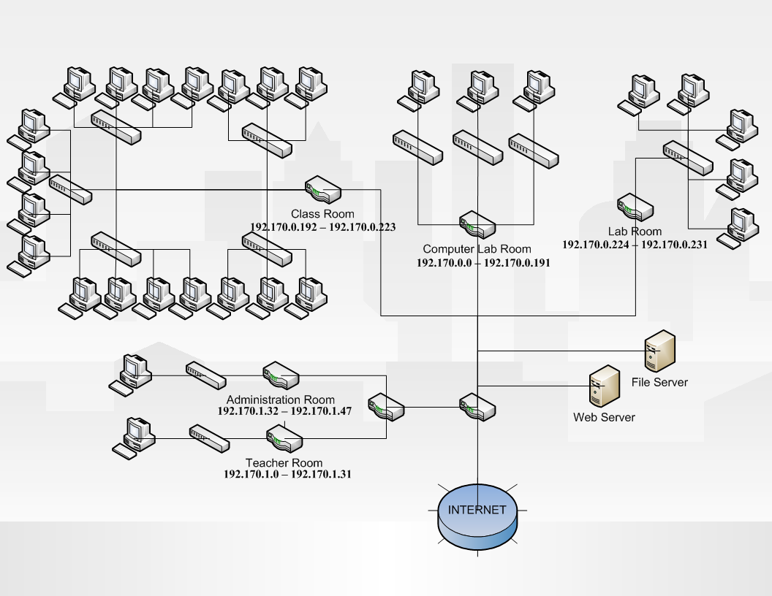**Lab Rooms (5) : 192.170.0.224 – 192.170.0.231**

Computer Lab Rooms (120 pc)

Di setiap ruangan ada 40 pc, setiap 10 pc terhubung ke switch tersendiri didalam ruangan, berarti di setiap ruangan ada 4 switch, lalu 4 switch tersebut terhubung ke satu switch untuk setiap ruangan lagi, berarti ada 3 switch yang terhubung ke satu router. Untuk internet connectionya agar dapat memenuhi kebutuhan dapat menggunakan fiber optic

Teacher Room (30 pc)

Di ruang guru ada 30 pc, dan setiap 10 pc terhubung ke switch tersendiri didalam ruangan, berarti di ruangan ada 3 switch, lalu 3 switch tersebut terhubung ke satu router

Administration Room (10 pc)

Di ruangan Administrasi ada 10 pc yang terhubung ke satu switch, dan switch tersebut terhubung ke satu router

Class Rooms (18 pc)

Di setiap ruangan ada 1 pc, dan setiap beberapa pc (+- 3pc s/d 4pc ) tersebut terhubung ke 1 switch yang berarti +- ada 5 switch yang terhubung ke satu router

Lab Rooms (5 pc)

Di setiap ruangan ada 1 pc yang terhubung ke satu switch, dan switch tersebut terhubung ke satu router

Computer Lab Room & Class Room & Lab Room

Router dari ruang lab computer, ruang kelas dan ruang lab terhubung ke 1 router utama

Teacher Room & Administration Room

Router dari ruang guru dan ruang administrasi terhubung ke satu router lainya dimana router tersebut terhubung ke router utama tanpa memperkenalkan RIP dari router ruang guru dan ruang administrasi

File Server & Web Server

File Server dan Web Server berada dalam 2 server yang berbeda guna mengurangi kemungkinan resiko terjadinya server down dan langsung terhubung ke main router

Main Router

Main router selain menghubungkan router-router lain maupun server dalam sekolah ia juga terhubung dengan internet